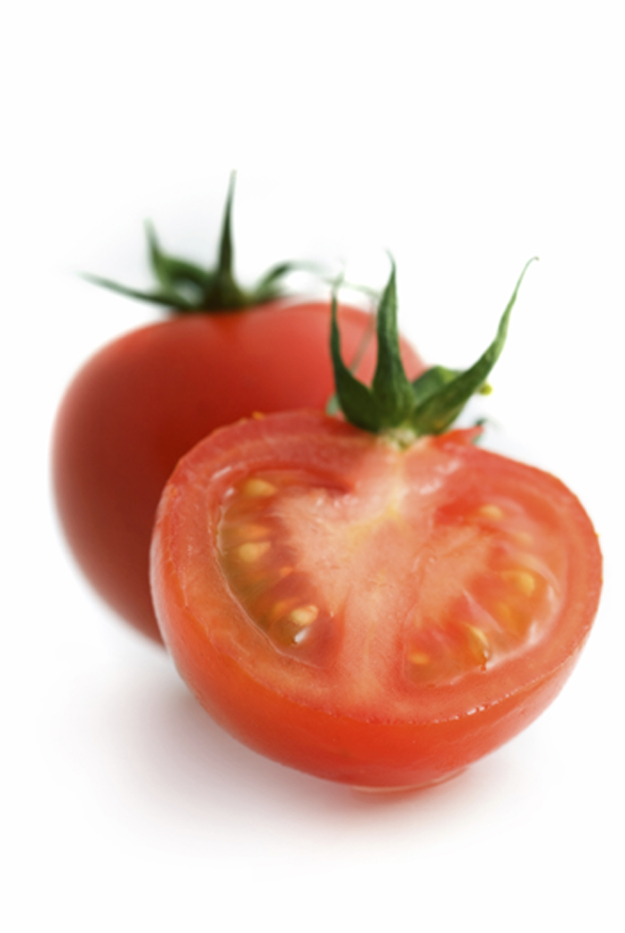Your Name’s World’s Best Tomato Sauce  For best flavor, use by December 2010 - Refrigerate after opening. Contents: Tomatoes, lemon juice.  See www.pickyourown.org/canning_tomatosauce.htm for directions and recipe. Please return the jar & ring when empty |  | Your Name’s World’s Best Tomato Sauce  For best flavor, use by December 2010 - Refrigerate after opening. Contents: Tomatoes, lemon juice.  See www.pickyourown.org/canning_tomatosauce.htm for directions and recipe. Please return the jar & ring when empty
Your Name’s World’s Best Tomato Sauce  For best flavor, use by December 2010 - Refrigerate after opening. Contents: Tomatoes, lemon juice.  See www.pickyourown.org/canning_tomatosauce.htm for directions and recipe. Please return the jar & ring when empty |  | Your Name’s World’s Best Tomato Sauce  For best flavor, use by December 2010 - Refrigerate after opening. Contents: Tomatoes, lemon juice.  See www.pickyourown.org/canning_tomatosauce.htm for directions and recipe. Please return the jar & ring when empty
Your Name’s World’s Best Tomato Sauce  For best flavor, use by December 2010 - Refrigerate after opening. Contents: Tomatoes, lemon juice.  See www.pickyourown.org/canning_tomatosauce.htm for directions and recipe. Please return the jar & ring when empty |  | Your Name’s World’s Best Tomato Sauce  For best flavor, use by December 2010 - Refrigerate after opening. Contents: Tomatoes, lemon juice.  See www.pickyourown.org/canning_tomatosauce.htm for directions and recipe. Please return the jar & ring when empty
Your Name’s World’s Best Tomato Sauce  For best flavor, use by December 2010 - Refrigerate after opening. Contents: Tomatoes, lemon juice.  See www.pickyourown.org/canning_tomatosauce.htm for directions and recipe. Please return the jar & ring when empty |  | Your Name’s World’s Best Tomato Sauce  For best flavor, use by December 2010 - Refrigerate after opening. Contents: Tomatoes, lemon juice.  See www.pickyourown.org/canning_tomatosauce.htm for directions and recipe. Please return the jar & ring when empty
Your Name’s World’s Best Tomato Sauce  For best flavor, use by December 2010 - Refrigerate after opening. Contents: Tomatoes, lemon juice.  See www.pickyourown.org/canning_tomatosauce.htm for directions and recipe. Please return the jar & ring when empty |  | Your Name’s World’s Best Tomato Sauce  For best flavor, use by December 2010 - Refrigerate after opening. Contents: Tomatoes, lemon juice.  See www.pickyourown.org/canning_tomatosauce.htm for directions and recipe. Please return the jar & ring when empty
Your Name’s World’s Best Tomato Sauce  For best flavor, use by December 2010 - Refrigerate after opening. Contents: Tomatoes, lemon juice.  See www.pickyourown.org/canning_tomatosauce.htm for directions and recipe. Please return the jar & ring when empty |  | Your Name’s World’s Best Tomato Sauce  For best flavor, use by December 2010 - Refrigerate after opening. Contents: Tomatoes, lemon juice.  See www.pickyourown.org/canning_tomatosauce.htm for directions and recipe. Please return the jar & ring when empty
Your Name’s World’s Best Tomato Sauce  For best flavor, use by December 2010 - Refrigerate after opening. Contents: Tomatoes, lemon juice.  See www.pickyourown.org/canning_tomatosauce.htm for directions and recipe. Please return the jar & ring when empty |  | Your Name’s World’s Best Tomato Sauce  For best flavor, use by December 2010 - Refrigerate after opening. Contents: Tomatoes, lemon juice.  See www.pickyourown.org/canning_tomatosauce.htm for directions and recipe. Please return the jar & ring when empty

